Tentative Table Structures

USERS TABLE

Profile_image is a boolean indicating if the uploaded one or not. We’ll have a table for profile_images later on

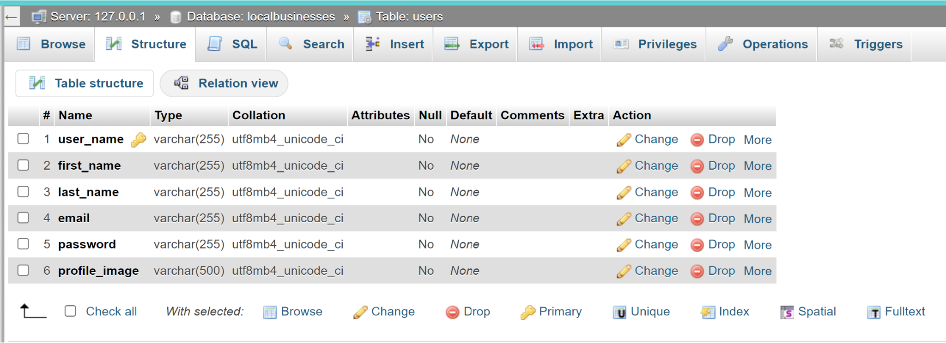

BUSINESSES TABLE

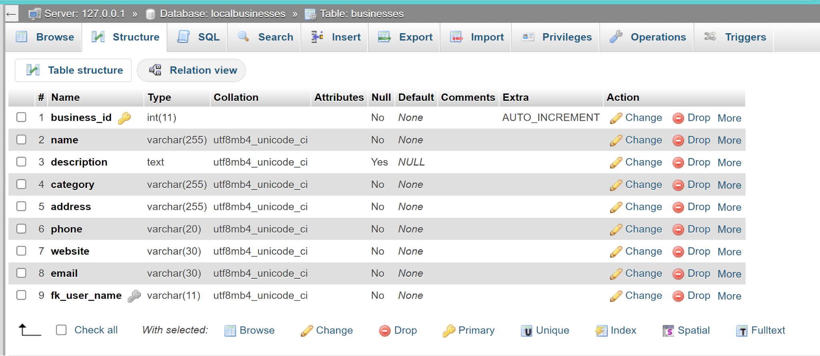

PROFILE IMAGE TABLE

Image_id

File_name

File_extension???

Alt (text to show if image not provided)

Fk_user_name (link back to users table)